Sky Reward App

# User Interface

2 Widgets: one on the left for user input and one of the right for output.

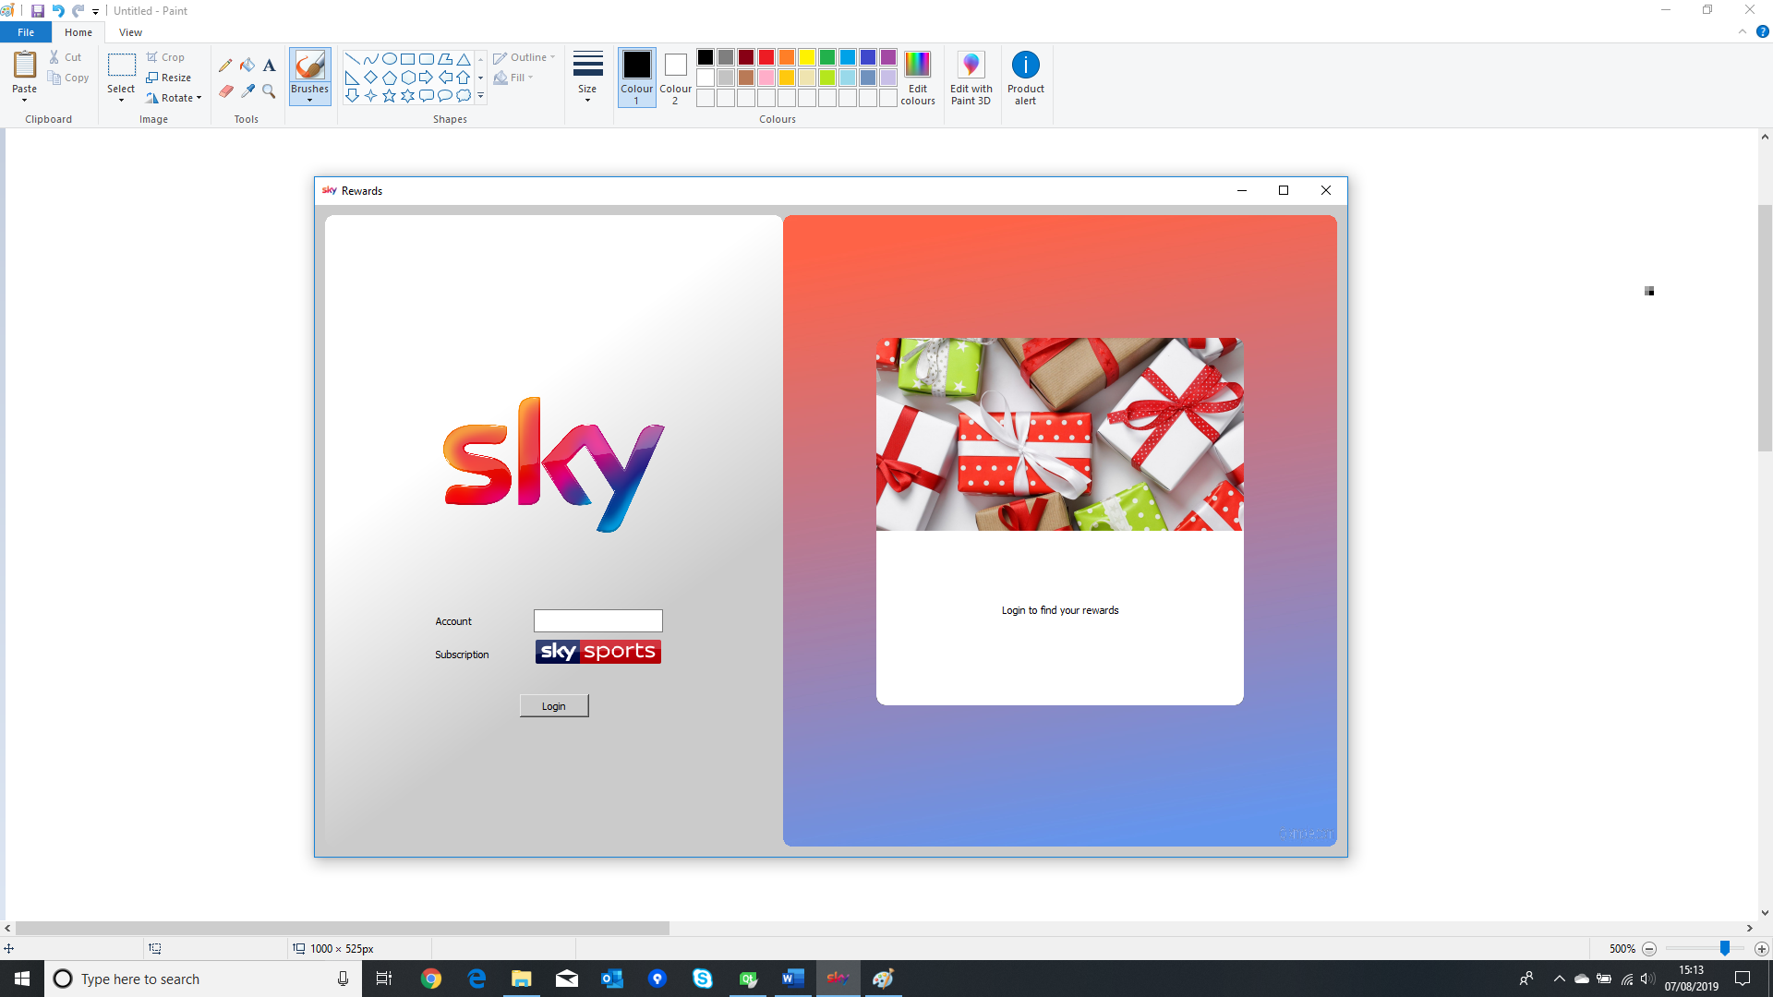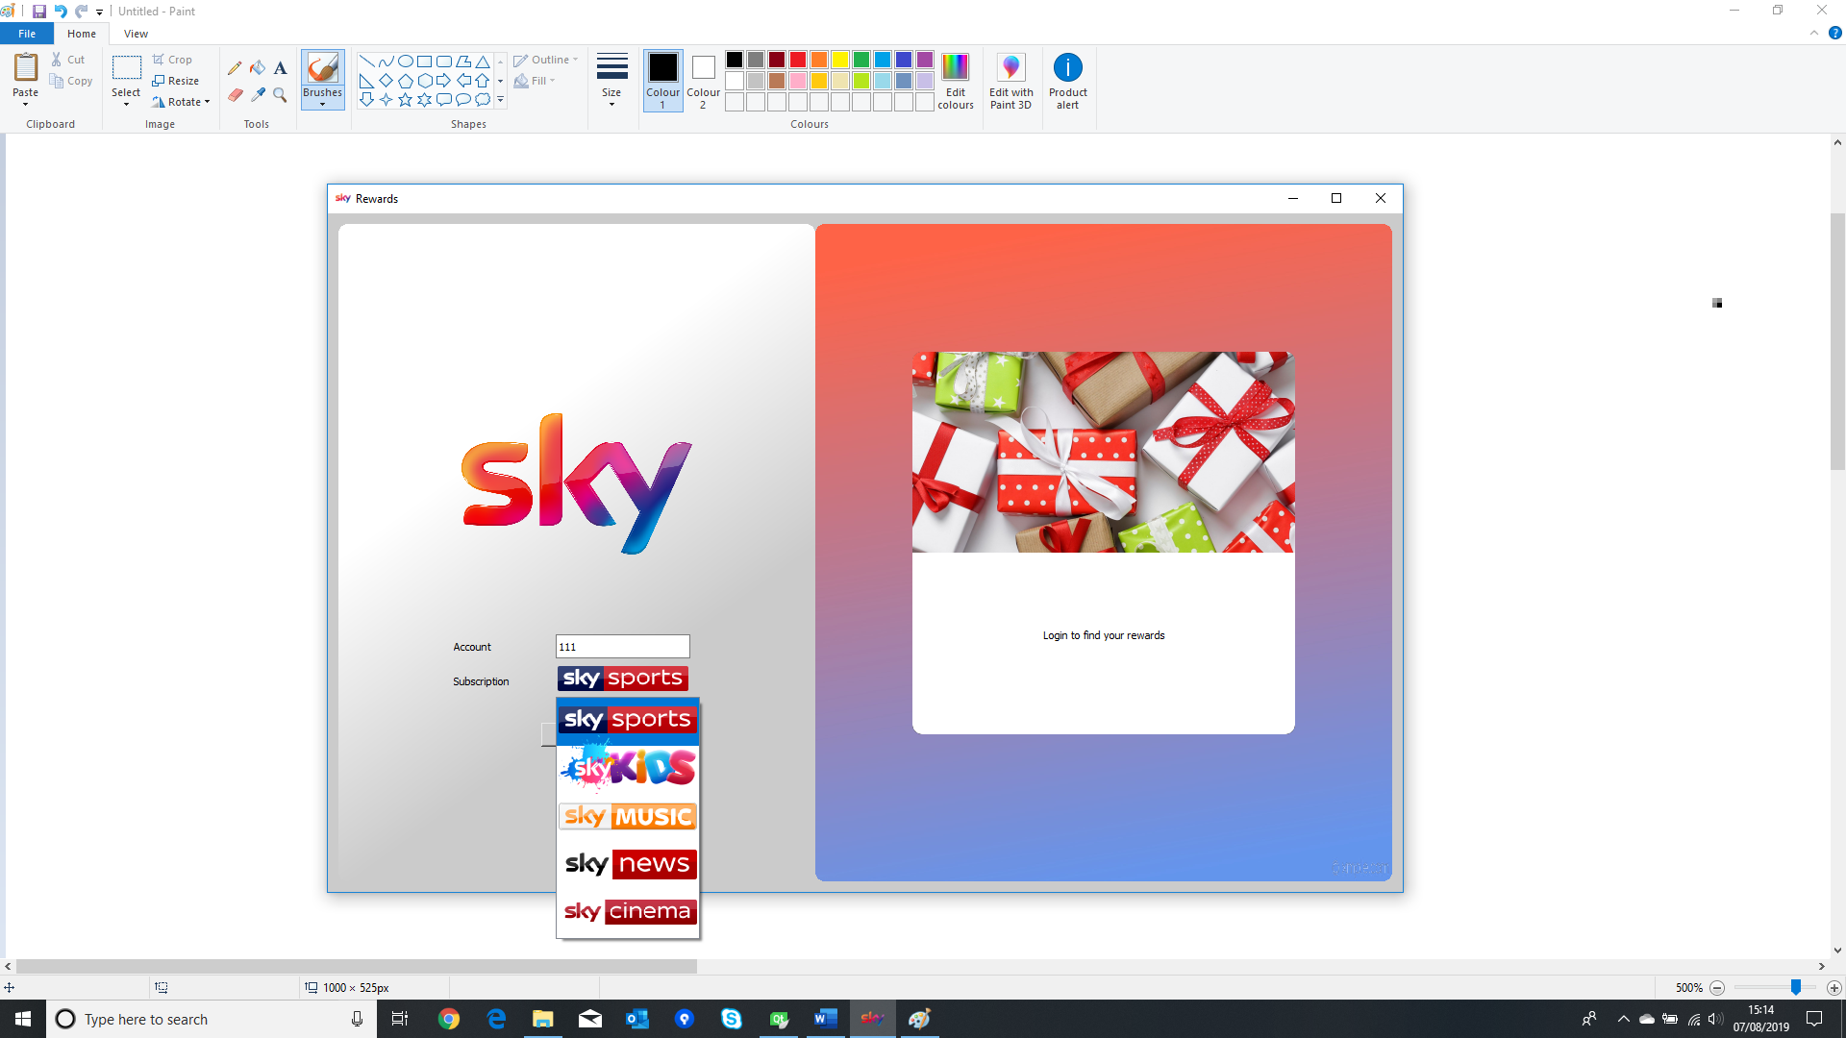

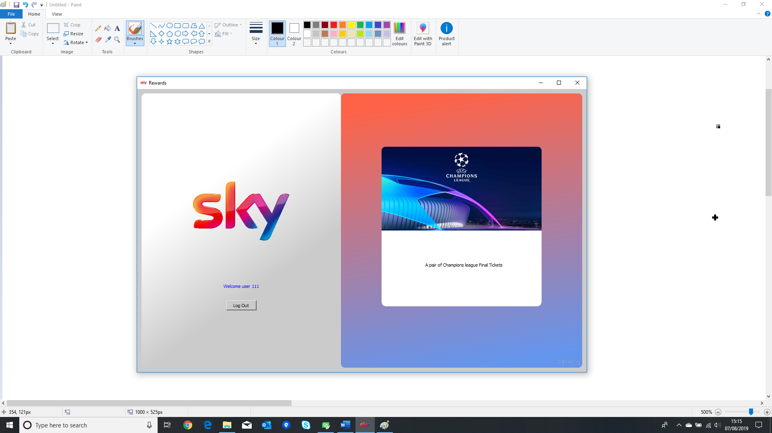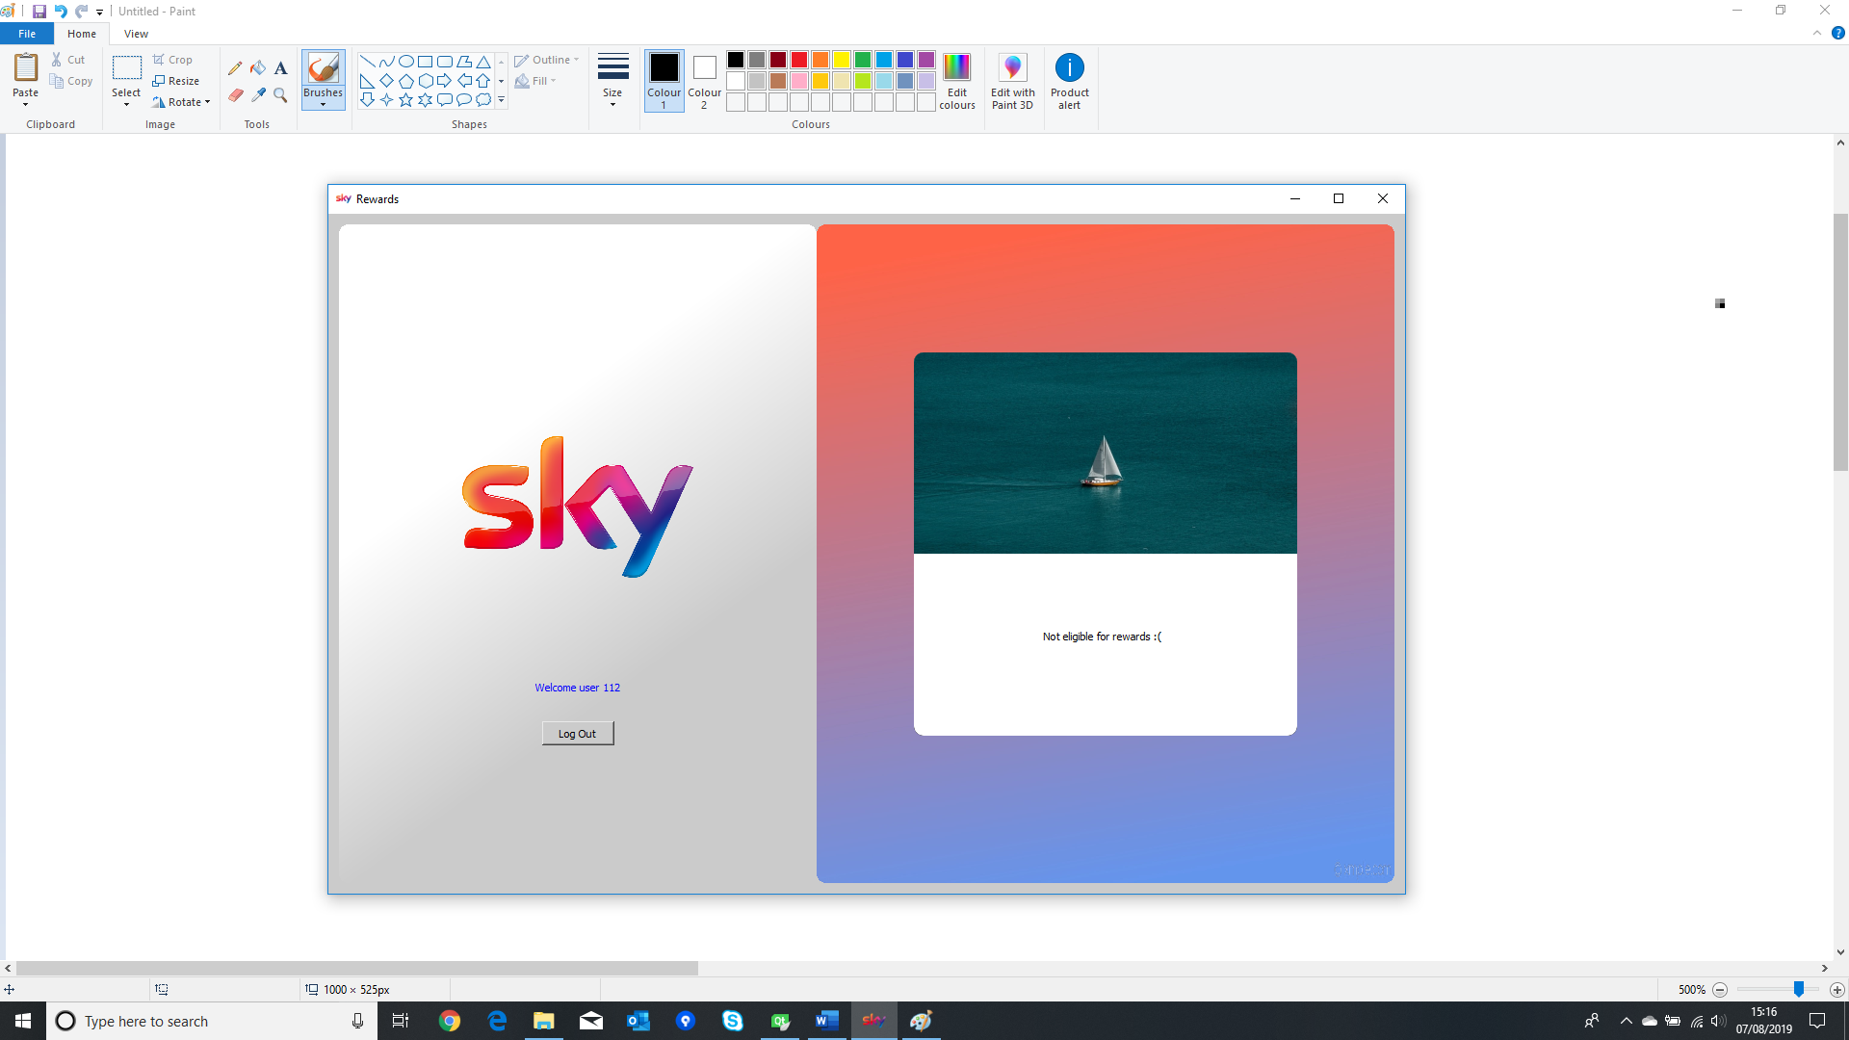

* When correct Account number and correct subscription is entered, user is shown welcome message and reward
* When correct Account number and incorrect subscription is entered, user is shown welcome message but no reward

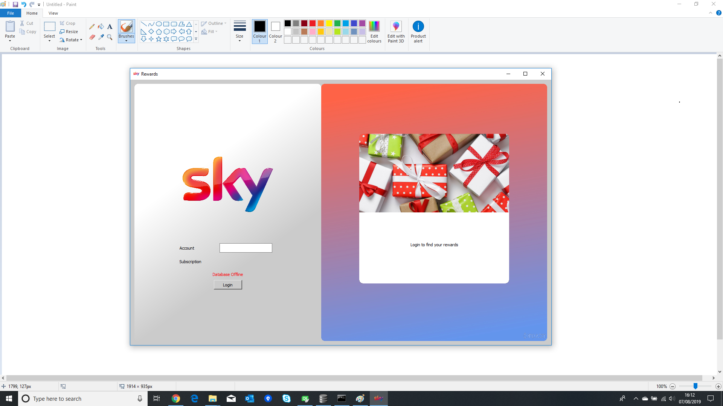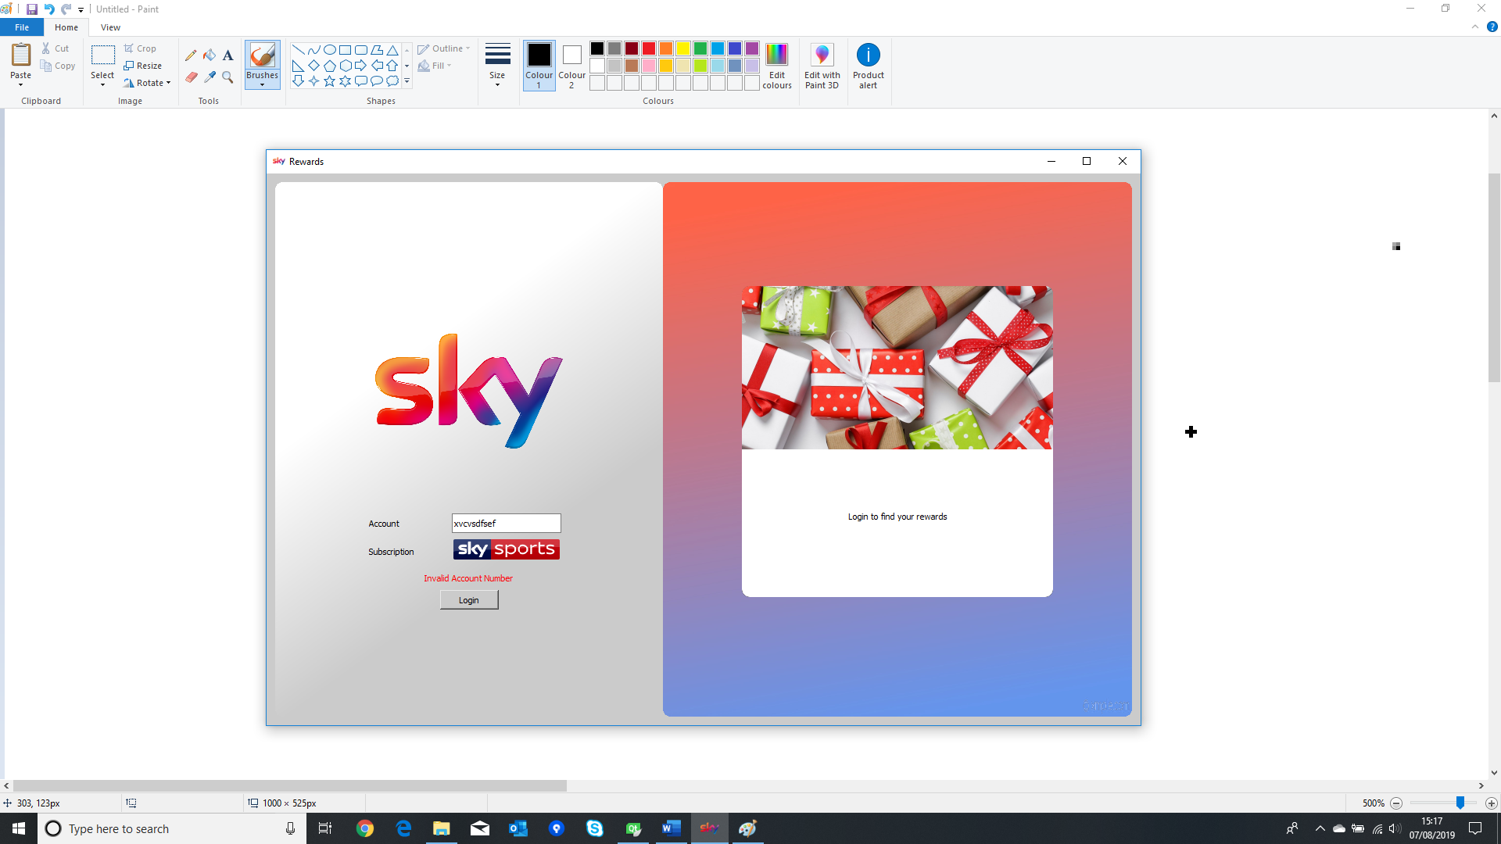

* When the SQLite database file (.db file) is missing, error message is shown. **Please copy “accounts.db” to the current folder of the application for the app to run correctly.**
* When incorrect Account number and correct subscription is entered

# Classes

1. Custom_graphicsview : shows the reward image and text in a rectagle with rounded corners
2. Custom_combobox : shows the list of available subscriptions as large images
3. Database : manages the SQLite database for user accounts and subscription details
4. Login : custom widget to take input from the user
5. Reward : custom widget to show reward to the user
6. Mainwindow : main window of the app

# Data

Data for user accounts ard subscription details are stored in SQLite .db file with two tables, one for user accounts and another for subscription and reward details. **Please copy “accounts.db” in the current folder of the application for the app to run.**

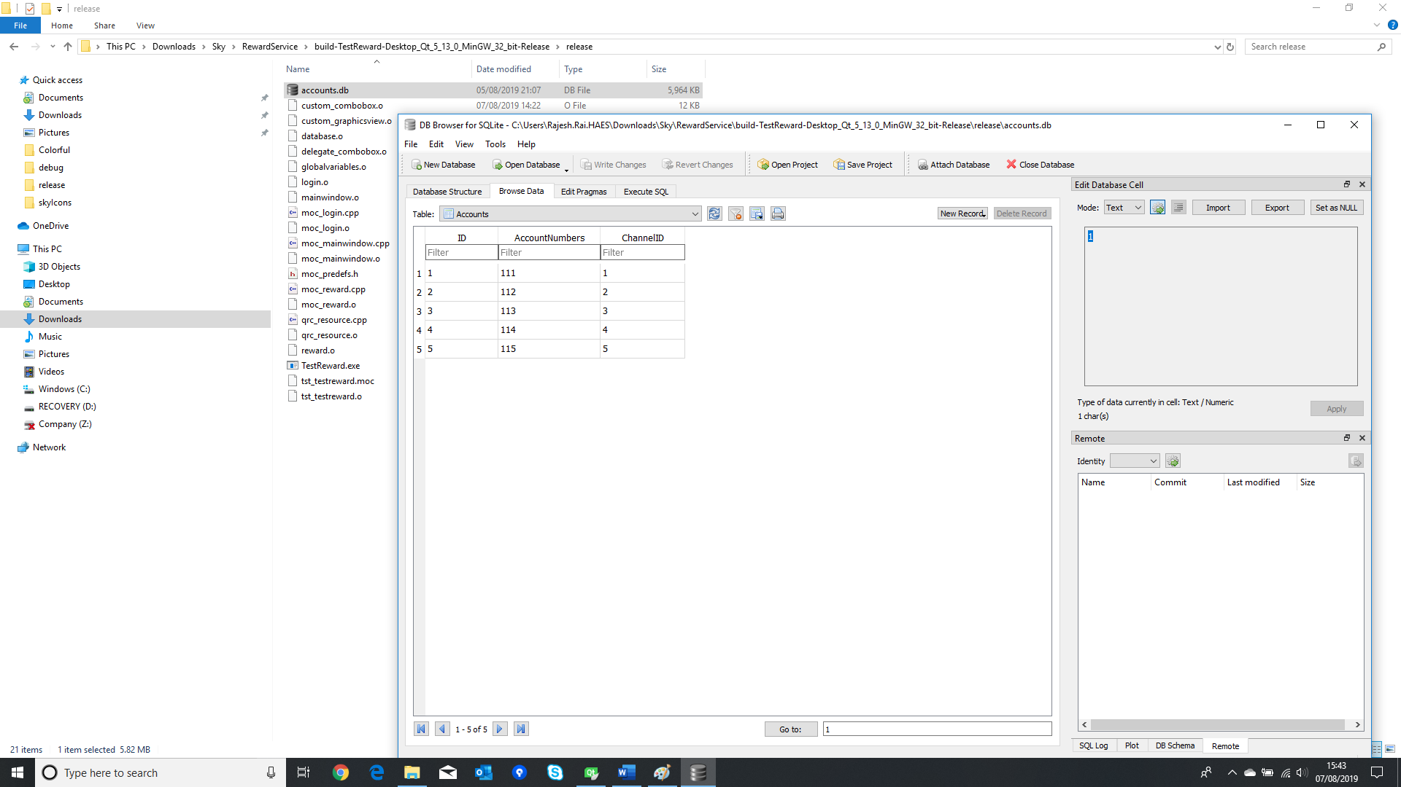

* Account table for user account number and subscription / channel

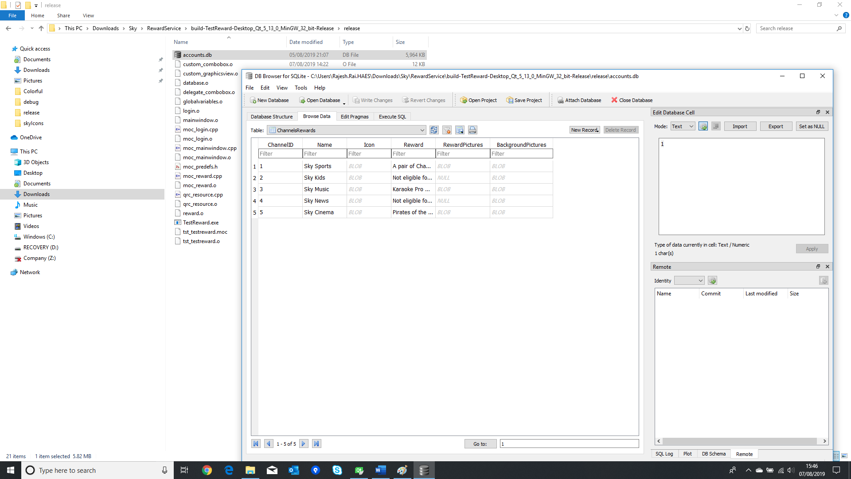

* Channel table for subscription and reward details.

# Unit testing

The app was tested using Qt Test framework. Created a test for each classes. Some of the classes could not as Custom_graphicsview and Custom_combobox were not tested directly as only “paintEvent” method was reimplement from their base class “QWidget”.

1. void **test_mainWindow**();
2. void **test_database**();
3. void **test_globalVariables**();
4. void **test_login**();
5. void **test_reward**();

Since all of the logic are applied in “void **test_login**();” and “void **test_reward**();” this is testing by entering known user account number as inputs and check if the outputs are produced correctly.